
./

Ver.Rel. No. | Release Date | Prepared. By | Reviewed By | Approved By | Remarks/Revision Details
 | 20/2/2022 | Nithin R
Document History

Table of Contents
Chapter No | Tittle | Page No
1. | Requirements and Analysis  - Empathize & research  - High-Level Requirement  - Low-Level Requirement  - SWOT Analysis  - 5W 1H | 2
2. | Design  - Block Diagram | 3
3. | Implement
4. | Evaluation | 4
5. | Summary

Case Study of RTCs With Temperature Display

1.Requirements:
- Empathize Research:

Real Time Clock is a digital clock which display real time. The clock provides seconds, minutes, hours, day, date, month, and year information. The end of the month date is automatically adjusted for months with fewer than 31 days, including corrections for leap year. The clock operates in either the 24-hour or 12-hour format with AM/PM indicator. It has a built-in power-sense circuit that detects power failures and automatically switches to the backup supply. Timekeeping operation continues while the part operates from the backup supply.

Analysis:
3 months to 5 months

- High-Level Requirement:
ID | Description
HR01 | Temperature display
HR02 | Time display

- Low-Level Requirement:
ID | Description | Datasheet
LR01 | RTC module
LR02 | OLed display
LR03 | Microcontroller
LR04 | Temperature sensor

- SWOT Analysis:

v. 5W 1H:

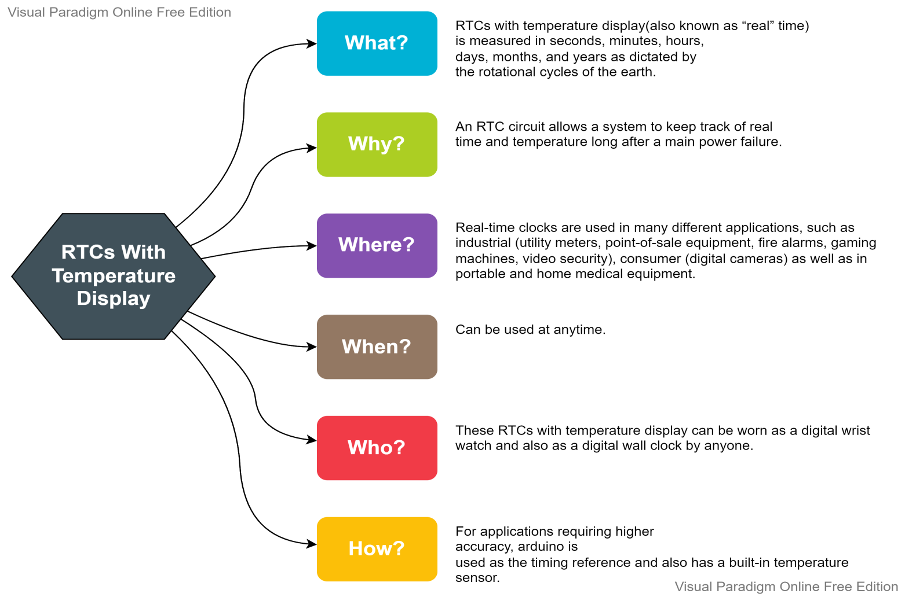

- Design:
- Block Diagrams:

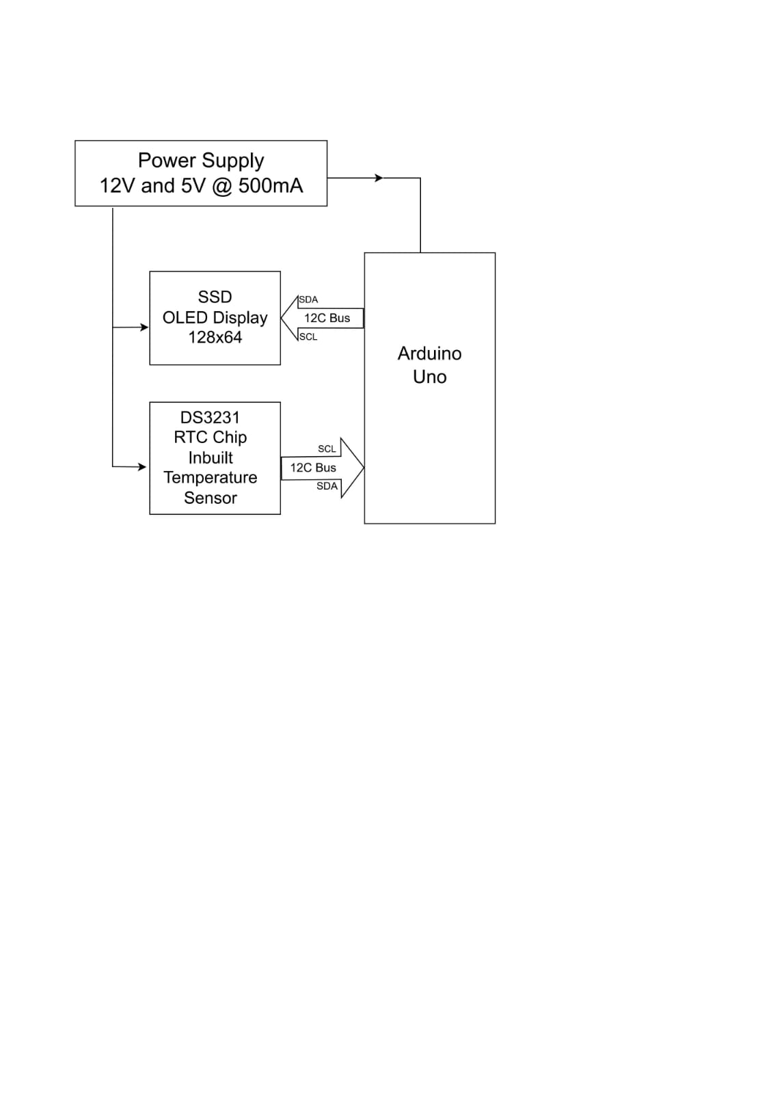

- Summary:
Real time clock with temperature display proposed in this case study helps to maintain real time clock and temperature necessary for various real time running systems even when there is no external power. Real time clock is commonly used in our computers, houses, offices and electronics device for keeping them update with real time. It is not only a real time clock but also a temperature sensing circuit. Temperature sensors are used to detect the room or body temperature. It can be developed to control other real time based operating systems such as regular warming the rice cooker, filling the water tank, checking the mail box and so on.
- REFERCES
- Floyd, (2007), T. L. Electronic Devices, 7th ed, New Jersey: Prentice-Hall International Inc.

- Goransson.A, (2013), AndroidTM Open Accessory ProgrammingTM+ ArduinoTM Project for the Evil Genius Arduino, John Wiley & Son inc.

